
Ministry of Higher Education
Misr Higher Institute for Commerce and computers
Computer Science Department

Kidney Diseases Diagnosis System
  - Team Members: -
Karim Nashat Ali
Mohamed Sherif Abd Elrahim
Amr Hany Mohamed
Moustafa Mahmoud Abd Elazeem

Omnia Maged Azzam
  - Supervisors: -
Dr/ Mahmoud Abu-Alfutuh
  - Assistant: -
Eng. Suad Abdul-Malik
2025/2026

Kidney Diseases Diagnosis System
  - Team Members:

Karim Nashat Ali
Mohamed Sherif Abd Elrahim
Amr Hany Mohamed
Moustafa Mahmoud Abd Elazeem

Omnia Maged Azzam
  - Supervisors: -
Dr/ Mahmoud Abu-Alfutuh
  - Assistant: -
Eng. Suad Abdul-Malik
2025/2026
  - Abstract
The Kidney Diseases Awareness System is designed to address the growing global challenge of undiagnosed and late-detected kidney disorders. Many kidney diseases begin with subtle or unnoticed symptoms, causing delays in diagnosis and increasing the risk of long-term complications. This project aims to provide a clear, accessible, and interactive platform that educates users about kidney disease, its symptoms, causes, risk factors, and preventive measures.
The system integrates an AI-powered symptom analysis module that allows users to select the symptoms they are experiencing. Based on these inputs, the system suggests possible kidney-related conditions and offers guidance to encourage early awareness and medical consultation. By combining technology with medical knowledge, this project seeks to enhance public awareness, support early detection, and promote healthier decision-making.
  - Table of Contents

CHAPTER 1: Project Description 2
1.1 Introduction 2
1.2 Problem Statement 3
1.3 Problem Statemen 4
1.4 Project Objectives 4
1.5 Scope of the Project 6
1.6 Previous Studies on Medical Diagnosis Systems 8
1.7 Project Limitations 9
CHAPTER 2: System Analysis 12
2.1 Problem Analysis 12
2.2 Existing Systems & Their Limitations 13
2.3 Proposed System Requirements 14
2.4 Use Case Modeling 15
2.5 System Workflow Description 18
2.6 Flowchart Diagram 20
2.7 Data Flow Diagrams (DFD) 23
2.8 DFD Level 1 24
2.9 Entity Relationship Diagram (ERD) 25
2.10 Sequence Diagram 27
CHAPTER 3: System Design & Architecture 31
3.1 Introduction 31
3.2 System Architecture 31
3.3 Technology Stack Selection 32
3.4 Database Design (Schema Definition) 32
3.5 System Design 35
3.6 User Interface Breakdown 36
3.7 Responsiveness 45
CHAPTER 4: Chapter 4 AI & ML Module 47
4.1 Introduction 47
4.2 Development Environment and Technology Stack 47
4.3 Data Engineering Pipeline 49
4.4 Model Development and Selection 51
4.5 Model Deployment and API Workflow 53
CHAPTER 5: System Implementation 55
5.1 Introduction 55
5.2 Implementation Environment 55
5.3 Backend Implementation 56
5.4 Security & Authentication Module 60
5.5 The Diagnosis Logic (Core Feature) 61
5.6 Database Connectivity 65
5.7 API Documentation (Key Endpoints) 65
5.8 AI Engine Implementation (Python Service) 66
5.9 Frontend Implementation 67
5.10 Asset Management (Public Folder Strategy) 68
5.11 Backend Integration & API 68
5.12 Server-Side Logic (Node.js) 69
5.13 Persistence Layer 70
5.14 Routing & Navigation Architecture 70
5.15 Data Flow & Component Logic 72
5.16 Deployment & Environment 73
CHAPTER 6: Conclusion 75
6.1 Conclusion 75

  - List of Tables

Figure ‎2-1:Use Case Diagram 16
Figure ‎2-2:Workflow Diagram 18
Figure ‎2-3:Flow chart Diagram 20
Figure ‎2-4:Context Diagram(DFD level 0) 23
Figure ‎2-5:DFD Level 1 24
Figure ‎2-6:Entity Relationship Diagram (ERD) 25
Figure ‎2-7:Diagnosis Process Sequence Diagram 27
Table 3.1: User Collection Design 33
Table 3.2: Diagnosis Collection Design 34
Figure ‎3-1: Home page 37
Figure ‎3-2: Login page 38
Figure ‎3-4: Test Page 40
Figure ‎3-5:Diet plan page 41
Figure ‎3-6:Contact page 42
Figure ‎3-7:About Our KidneyCare 43
Figure ‎3-8: Profile Page 44
Figure ‎4-1:Random Forest Architecture Diagram 51
Figure ‎5-1:config 57
Figure ‎5-4:use Symptom Controller 59
Figure ‎5-5: password hashing 60
Figure ‎5-6:Token Generate 61
Figure ‎5-7:Verify Token Admin 61
Figure ‎5-8:Diagnosis Controller Implementation 64

Chapter 1

Project Description

Project Description

Introduction
Kidney diseases are among the most widespread chronic health issues worldwide, affecting millions of individuals each year. A primary challenge in managing kidney conditions is that most of them develop silently and are asymptomatic. Symptoms often start mild, such as fatigue, swelling, or subtle changes in urination, which make early detection difficult. Consequently, many patients only discover their condition in advanced stages, where treatment becomes more complex and less effective.
With the increasing rates of diabetes, hypertension, and obesity, the risk of kidney-related complications continues to rise. However, public awareness of kidney health remains limited. Many individuals lack knowledge about the early symptoms, risk factors, and long-term impact of ignoring minor health changes. This gap in awareness contributes significantly to late diagnoses and preventable kidney damage in patients with PKD.
The Kidney Disease Awareness System was developed to address these issues by providing a simplified, accessible, and reliable source of kidney health information. The system offers educational material on common kidney diseases, their symptoms, causes, diagnostic methods, and prevention strategies. Additionally, it includes an AI-powered module that analyzes selected symptoms and suggests potential conditions based on medical knowledge. This helps guide users toward a better understanding of their health status and encourages timely medical consultation.

Problem Statement
Kidney diseases often go unnoticed in their early stages, leading to late diagnosis and an increased risk of severe complications, including kidney failure. Many individuals lack proper awareness of early symptoms, risk factors, and prevention methods. The absence of accessible and interactive educational platforms contributes to the growing number of undiagnosed kidney-related conditions.
This project aims to solve the problem of limited awareness by creating a system that educates users and helps them understand their symptoms through an AI-assisted module.

Problem Statemen
The project is important because of the following reasons:
- Kidney diseases are increasing globally due to diabetes, hypertension, and lifestyle related factors.
- Early detection significantly improves treatment outcomes and prevents complications from occurring.
- Many people ignore early symptoms because of a lack of awareness.
- An easy-to-use system can guide users toward medical consultation before their conditions worsen.
- This project supports public health goals by promoting preventive awareness.

Project Objectives

General Objective
The main goal of this project is to design and develop an intelligent, web-based Kidney Diseases Diagnosis System that leverages Artificial Intelligence to educate the public, analyze user symptoms, and bridge the gap between patients and early medical diagnosis.

Specific Objectives
The specific objectives of the Kidney Diseases Awareness System are:
- Provide clear and scientifically accurate educational content about the most common kidney diseases, including their symptoms, causes, diagnosis methods, and prevention strategies.
- Offer an interactive symptom-input interface that enables users to select their symptoms easily and intuitively.
- Deliver AI-powered preliminary guidance based on user symptoms to help identify potential kidney-related conditions.
- Encourage early medical consultation by raising awareness of risk levels and warning signs.
- Support preventive healthcare practices by offering lifestyle recommendations related to hydration, diet, exercise, and early screening.
- Ensure a user-friendly digital experience suitable for all age groups through clear navigation, responsive UI design, and accessible content display.
- Provide a structured disease library that organizes kidney disease information into categories for easy exploration.
- Enhance decision-making for users by presenting tailored awareness messages and risk explanations generated using lightweight AI models.

Scope of the Project
The scope of the Kidney Diseases Awareness System focuses on delivering an educational, interactive, and AI-assisted platform designed to enhance public understanding of kidney health. The system is structured around clear functional boundaries and aims to provide users with reliable information, intuitive tools, and early awareness insights. Its scope includes the following core elements:

Centralized Educational Repository
The system offers a comprehensive and simplified knowledge base covering most common kidney diseases. It presents essential medical information including symptoms, causes, risk factors, diagnostic procedures, and prevention guidelines in clear, accessible language suitable for the public.
This repository bridges the gap between complex medical terminology and user-friendly understanding.

Interactive Disease Exploration
Users can explore detailed profiles of each kidney disease through structured, easy-to-navigate sections.
The system provides medical explanations, early warning signs, potential complications, and recommended lifestyle practices.
This interactive format allows users to learn at their own pace and focus on information relevant to their health concerns.

AI-Driven Symptom Analysis
A key feature of the system is an intelligent symptom-checking module. Users can select symptoms they experience from a predefined list, and the AI component analyzes these inputs to provide preliminary suggestions about potential kidney-related conditions.
This module is designed to support awareness and early indication, not medical diagnosis.

Promoting Early Intervention
By providing clear health insights and highlighting possible risks, the system encourages users to seek timely professional medical consultation.
The focus is on raising awareness, increasing preparedness, and supporting the early recognition of kidney-related disorders.

Previous Studies on Medical Diagnosis Systems
Several studies and digital health platforms have been developed to support medical awareness through technology. Prominent systems such as Ada Health, Mayo Clinic Symptom Checker, and WebMD offer general symptom assessments covering a wide range of diseases. Additionally, other research projects in the medical domain have utilized questionnaires and digital tools to help patients understand their potential conditions.
However, a review of these existing systems reveals certain limitations. While they provide useful insights, they often lack a specialized focus on renal health and do not always combine detailed disease education with specific AI-based symptom predictions. Most are designed as broad diagnostic tools rather than educational platforms tailored for specific organ health.
In contrast to these general systems, the Kidney Diseases Awareness System is designed to address this gap. It focuses specifically on kidney health, offering more targeted guidance, clearer symptom descriptions, and tailored recommendations that general platforms may overlook. This specialization ensures that users receive relevant information without being overwhelmed by unrelated medical data

Project Limitations
While the Kidney Diseases Diagnosis System provides an effective platform for education and preliminary symptom assessment, the system operates within clearly defined medical and technical boundaries. These limitations ensure proper ethical use and clarify the scope of the project.

Non-Diagnostic Nature
This system is strictly an educational and awareness tool and must not be interpreted as a medical diagnostic system. It does not:
- Perform clinical or laboratory evaluations.
- Provide confirmed medical diagnoses.
- Prescribe medications or treatment plans.
- Replace professional medical consultation.
Its primary function is to guide and inform users, encouraging them to seek professional healthcare when necessary.

Dependency on Dataset and User Input Quality
The accuracy of the AI-generated symptom suggestions depends heavily on:
- The quality, diversity, and completeness of the dataset used for training.
- The accuracy and honesty of the symptoms selected by the user.
Any incomplete or incorrect symptom input can reduce the reliability of the generated suggestions.

Limited Disease Coverage
To maintain clarity, accessibility, and educational value, the system focuses on the five most common kidney diseases.
Rare, complex, or highly specialized kidney conditions, especially those requiring advanced clinical evaluation, beyond the current scope of this study

Chapter 2

System Analysis

System Analysis

Problem Analysis
The current approach to kidney health management is often reactive rather than preventive. Patients frequently seek medical attention only after symptoms have progressed to advanced stages, where treatment becomes complex and less effective. The analysis of the current situation identifies three core problems:

The "Silent" Nature of the Disease:
Most kidney diseases are asymptomatic in their early stages. Subtle signs like fatigue or minor changes in urination are often ignored by patients due to a lack of knowledge

Information Gap:
While medical information exists online, it is often dispersed, overly technical, or difficult for the public to interpret. There is a distinct lack of centralized, simplified platforms dedicated specifically to renal health.

Lack of Specialized Digital Tools:
Most existing digital health tools are general-purpose. They do not provide the specialized AI-driven guidance needed to detect the specific nuances of kidney-related symptoms.

Existing Systems & Their Limitations
Several digital health platforms currently exist to support general medical awareness. However, upon analyzing these systems, specific limitations regarding kidney health were identified:

General Symptom Checkers (e.g., WebMD, Mayo Clinic):
These platforms cover a vast range of diseases. Their broad scope often leads to vague results that may not accurately highlight kidney-specific risks.

Hospital Appointment Apps:
These applications focus primarily on administrative tasks, such as booking slots, rather than educating the user or analyzing their health status.

Static Medical Websites:
Many health websites provide text-based articles without any interactive features to engage the user or analyze their specific symptoms.

Conclusion of Analysis
None of the existing systems combine specialized kidney education with an interactive, AI-based symptom selector in a simplified user interface. This confirms the necessity of the Kidney Diseases Awareness System to bridge this gap.

Proposed System Requirements
This section outlines the specific requirements necessary for the implementation of the Kidney Diseases Awareness System. These are categorized into Functional Requirements, which define the system's behaviors, and Non-Functional Requirements, which specify the system's quality attributes

Functional Requirements (FRs)
- FR1: User Registration & Authentication The system must provide a secure interface that allows users to create personal accounts and log in. This feature ensures that users can securely access personalized kidney health records and save their assessment history.
- FR2: Symptom Selection Interface The frontend must provide an interactive interface displaying a predefined list of symptoms (e.g., fatigue, swelling). Users shall select the applicable symptoms rather than typing them manually, ensuring data accuracy before submission to the AI module for analysis.
- FR3: Disease Information Display The system shall present comprehensive educational content covering the five most common kidney diseases. This information must be displayed in a responsive, structured, and easy-to-read layout to ensure maximum readability for the public.
- FR4: AI Result Visualization The user interface must clearly visualize the preliminary guidance and suggested conditions returned by the AI module. The display should include the potential condition, the estimated risk level, and a clear disclaimer advising medical consultation.

Non-Functional Requirements (NFRs)
- NFR1: Usability The interface must be intuitive and user-friendly, suitable for all age groups. Navigation between the symptom checker and educational content should be simple and consistent to minimize user effort.
- NFR2: Responsiveness The application must be fully responsive, effectively adapting its layout to various screen sizes (mobile, tablet, and desktop) using modern flexible CSS layouts.
- NFR3: Performance The frontend should ensure rapid loading times, with initial content rendering in under 3 seconds to guarantee smooth and efficient user experience.
- NFR4: Security User data must be protected; passwords must be hashed (encrypted) before storage in the database. Furthermore, all API endpoints must be secured against unauthorized access to prevent data breaches.

Use Case Modeling
The Use Case diagram provides a graphical representation of the system's functional requirements. It illustrates the interaction between the external actors (User and Admin) and the system's core functionalities.
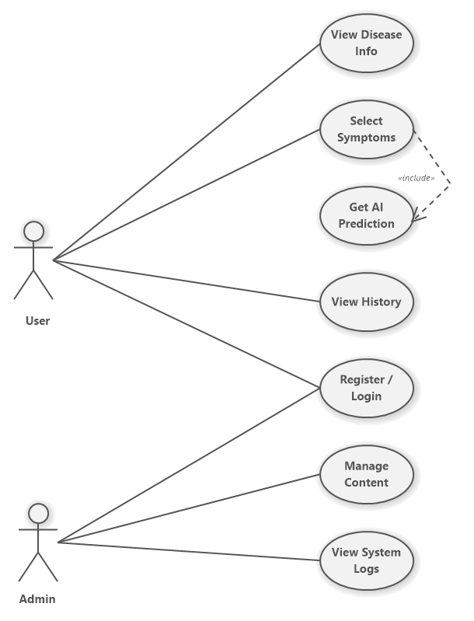
Figure ‎2-1:Use Case Diagram

The Actors (Who uses the system?)
• The User: This is the patient or visitor who wants to check their health or learn about kidney diseases.
• The Admin: This is the manager who updates the medical information and monitors the system.

How the System Works (User Interactions)
- Symptom Checking: The user does not need to type. They simply select their symptoms from a checklist. Once they submit, the system automatically runs the AI prediction to show the result. This explains the «include» relationship in the diagram: choosing symptoms automatically leads to getting a prediction.
- Education: The user can browse the "Disease Info" section to read about symptoms and prevention without needing to log in.
- History: If the user creates an account and logs in, they can save their results and view their previous history.

Admin Interactions
The Admin enters the system to Manage Content. This means they can add new diseases or update existing health tips. They can also view System Logs to ensure everything is working correctly

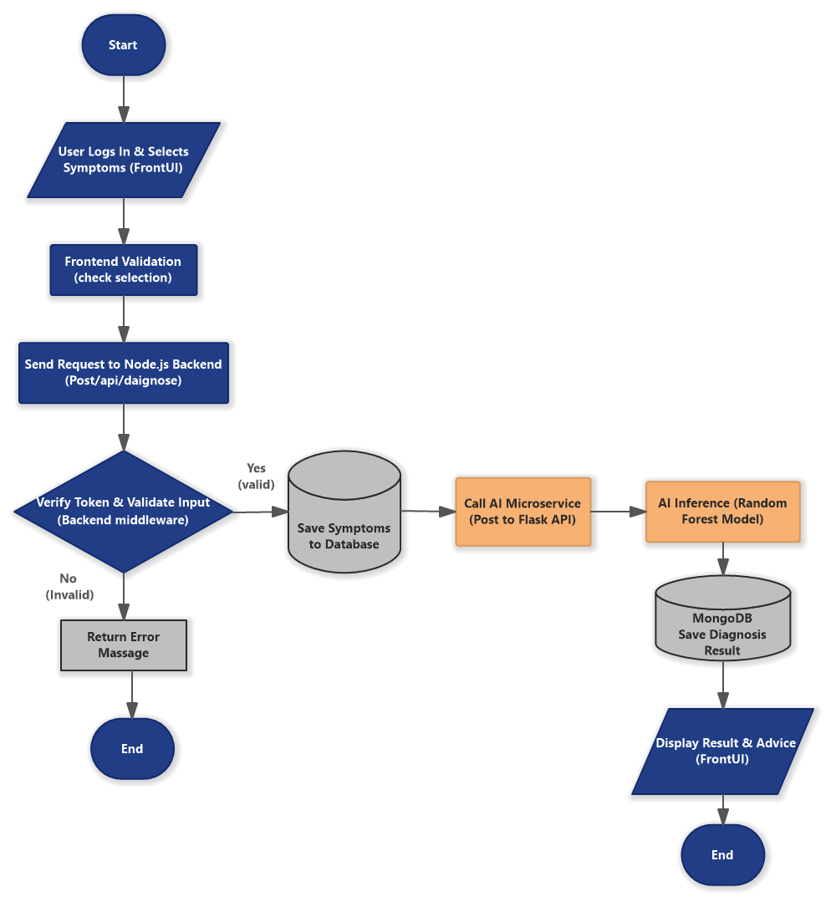
System Workflow Description
Figure ‎2-2:Workflow Diagram

Description: The revised workflow diagram illustrates the precise technical sequence of the diagnosis process, highlighting the integration between the Node.js backend and the Python AI microservice:
- Data Input: The process begins when the authenticated user accesses the "Symptom Wizard" and selects their current symptoms (e.g., Fever, Back Pain) from the predefined list.
- Validation & Persistence:
  - The frontend ensures data completeness before transmission.
  - Upon receiving the request, the Node.js Backend verifies the user's authentication token (JWT) and validates the input format.
  - Valid symptoms are immediately saved to the MongoDB database to ensure no data is lost.
- AI Interoperability: The backend triggers an internal API call to the Python Microservice. This service preprocesses the symptoms and feeds them into the Random Forest Model.
- Result Processing: The AI model returns the predicted disease and a confidence score. The Node.js server records this final diagnosis in the database linked to the user's profile.
- Output: Finally, the system displays the diagnosis result along with tailored medical advice to the user interface.

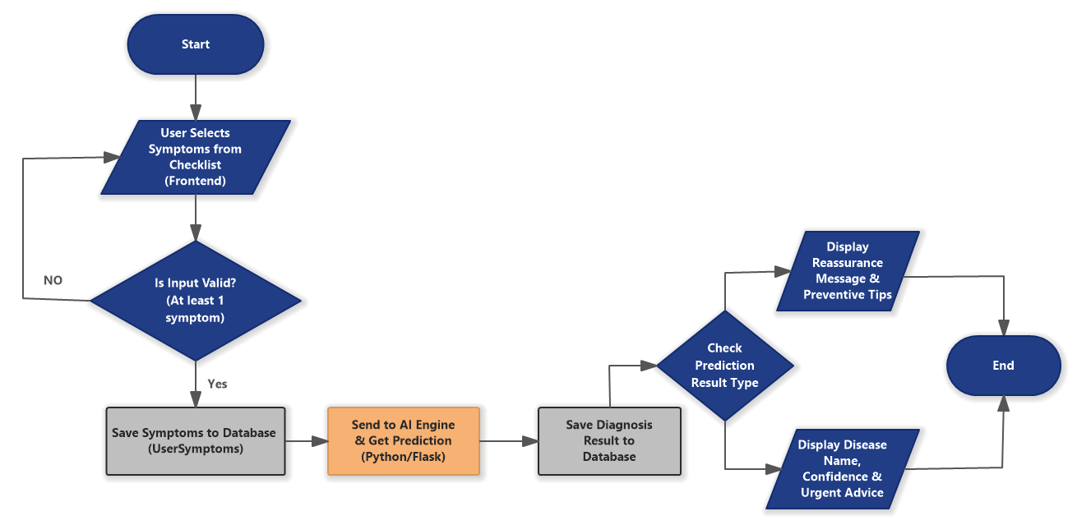
Flowchart Diagram
Figure ‎2-3:Flow chart Diagram

Description: The flowchart illustrates the logical sequence of operations performed by the system during the diagnosis process, detailing the decision-making path from user input to the final medical advice:
- Start: The process initiates when the user navigates to the "Tests" page.
- Input: The user interacts with the UI to Select Symptoms from the provided checklist.
- Validation: The system checks if the input is valid (at least one symptom selected).
  - No: The system prompts the user to correct the input.
  - Yes: The process moves to the backend.
- Data Persistence: The selected symptoms are immediately Saved to the Database to ensure a record exists before processing.
- AI Processing: The system invokes the AI engine to analyze the symptom pattern and calculate a confidence score.
- Result Storage: The prediction result is saved in the Diagnosis collection.
- Decision (Result Type):
  - If Healthy: The system displays a reassurance message with general preventive tips.
  - If Risk Detected: The system displays the specific disease name, the confidence percentage, and urgent medical advice.
- End: The process concludes by presenting the final report to the user.

- The workflow starts when the User Inputs Data (lab values).
- The system performs Data Preprocessing to clean and prepare the input.
- A validation step checks whether the entered data is valid.
  - If the data is invalid, the system displays an Error Message and stops further processing.
- If the data is valid, it is fed into the Random Forest Model for classification.
- The model performs Analysis & Voting to determine the most likely diagnosis.
- The system then checks the Final Classification Result:
- If the result is 0, the system displays: "Healthy – No Prevention Needed."
  - If the result is between 1 and 5, the system displays the specific disease type along with recommended prevention steps.
- The workflow ends after the result is displayed to the user.

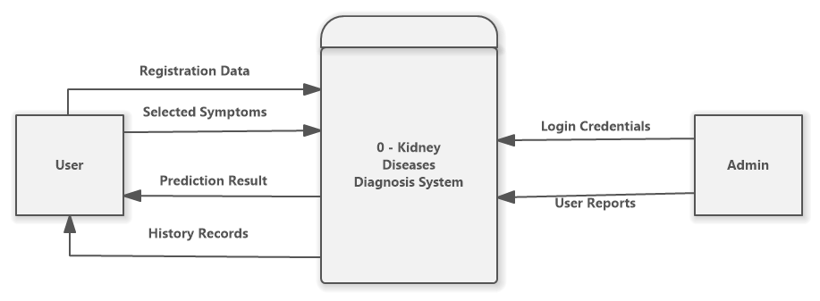
Data Flow Diagrams (DFD)
Figure ‎2-4:Context Diagram(DFD level 0)

Description: The Context Diagram (Level 0) provides a high-level view of the Kidney Diseases Awareness System. It illustrates the system's boundary and its interaction with external entities. The diagram identifies two primary actors:
- User: Interacts with the system by providing registration details and selecting symptoms. In return, the user receives AI-based prediction results and access to their medical history.
- Admin: Responsible for managing the system securely. The admin provides login credentials to access the dashboard and retrieves user reports for monitoring purposes.
The central process represents the entire software solution, acting as a bridge between the users' inputs and the analytical outputs.

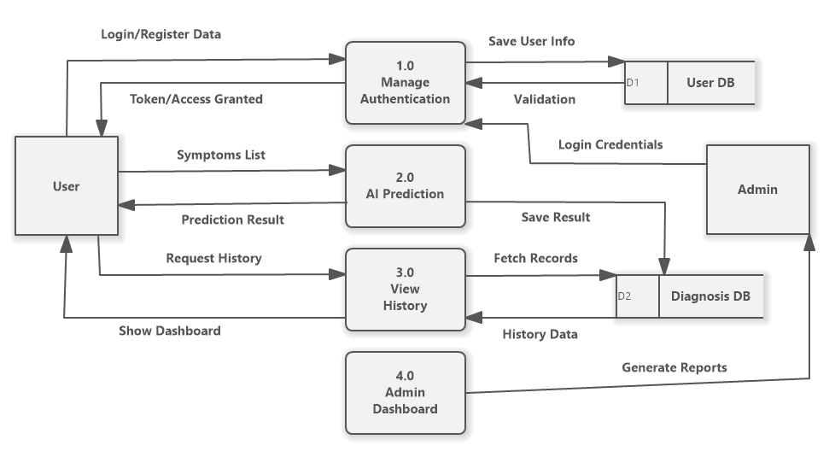
DFD Level 1
Figure ‎2-5:DFD Level 1

Description: The Level 1 Data Flow Diagram decomposes the system into its core functional processes, highlighting how data flows between these processes and the data stores. The system is divided into three main processes:
- 1.0 Manage Authentication: Handles user registration and login. It validates credentials against the User DB and grants access tokens to authorize further actions.
- 2.0 AI Prediction: This is the core engine where the user submits a "Symptoms List." The process sends this data to the AI model and stores the "Prediction Result" in the Diagnosis DB.
- 3.0 View History: Allows users to request their past assessments. It fetches records from the Diagnosis DB and displays them on the user's dashboard.
This diagram clarifies the logical flow of information and ensures that data storage (User DB and Diagnosis DB) is properly linked to the relevant operations.

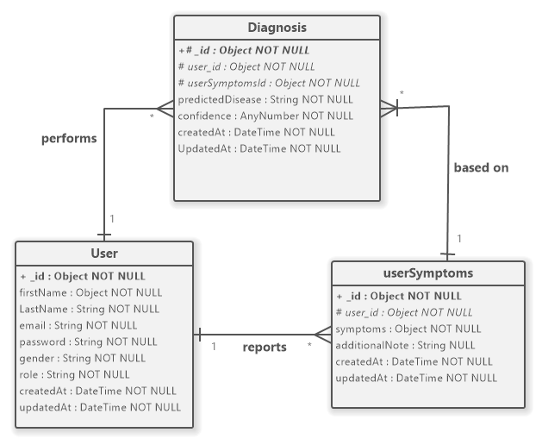
Entity Relationship Diagram (ERD)
Figure ‎2-6:Entity Relationship Diagram (ERD)

Description: The Entity Relationship Diagram (ERD) visualizes the logical structure of the database, defining the entities, their attributes, and the relationships that govern data integrity. The schema is composed of three main entities:
- User: This is the parent entity containing user credentials and profile information (firstName, email, role, password). It serves as the source of identity for all operations.
- Diagnosis: This entity stores the results of the AI analysis, including the predictedDisease and the confidence score.
  - Relationship: There is a One-to-Many relationship between User and Diagnosis (User performs Diagnosis), meaning a single user can perform multiple diagnosis tests over time.
- userSymptoms: This entity records the specific inputs provided by the user (the symptoms object and additionalNote) for a specific test.
  - Relationship: There is a One-to-One relationship between Diagnosis and userSymptoms (Diagnosis is based on userSymptoms). This ensures that every diagnosis result is strictly linked to the specific set of symptoms that generated it, allowing for accurate historical review.

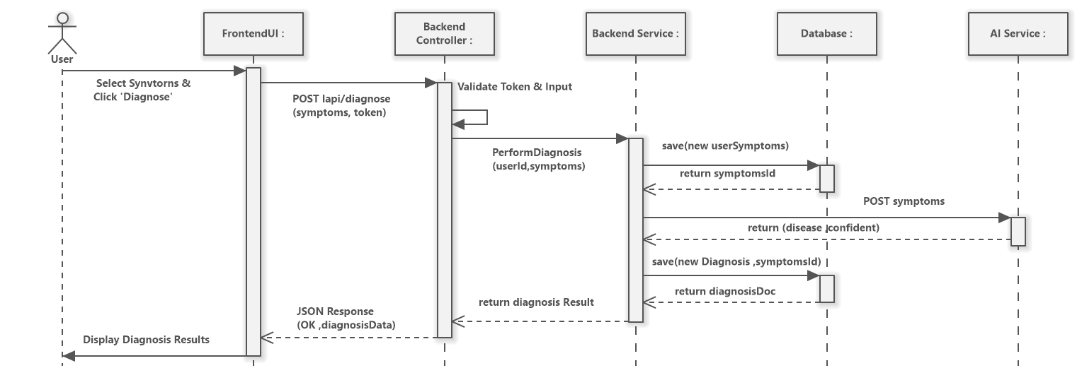
Sequence Diagram
Figure ‎2-7:Diagnosis Process Sequence Diagram
The Sequence Diagram provides a dynamic view of the system, illustrating the chronological sequence of messages exchanged between the different system components to complete a specific task. The following diagram details the "Diagnosis Process," highlighting the interaction between the Frontend, Node.js Backend, Database, and the Python AI Microservice.
Description: The diagram visualizes the lifecycle of a diagnosis request, involving five key lifelines:
- User: Initiates the process by interacting with the UI.
- Frontend (React): Captures user input and manages API requests.
- Backend (Node.js): Acts as the central controller, handling validation, database operations, and external service calls.
- Database (MongoDB): Ensures data persistence for both symptoms and diagnosis results.
- AI Service (Python): Executes the Random Forest model for disease prediction.
Process Flow:
- Initiation: The user selects their symptoms on the frontend and clicks "Analyze".
- Request: The Frontend sends an HTTP POST request containing the symptom vector to the Node.js Backend.
- Symptom Persistence: Before processing, the Backend saves the raw symptoms into the MongoDB database (UserSymptoms collection). This ensures that user data is secured even if the AI service encounters an error.
- AI Inference: The Backend triggers an internal API call to the Python Microservice, passing the saved symptom data.
- Prediction: The Python service processes the data using the pre-trained Machine Learning model and returns the predicted disease and confidence score to the Backend.
- Result Persistence: The Backend updates the database by saving the final diagnosis result linked to the user's ID and symptom record.
- Response: Finally, the Backend sends the structured diagnosis report back to the Frontend, which displays the result and medical advice to the user.

Chapter 3

System

Design & Architecture

System Design & Architecture

Introduction
Following the system analysis presented in the previous chapter, this chapter details the architectural blueprints and technological decisions made to build the "Kidney Diseases Awareness System". It focuses on the software architecture, database schema specifications, and the detailed user interface design strategy

System Architecture
The system adopts a Three-Tier Architecture integrated with a specialized AI Microservice. This separation ensures scalability, maintainability, and clear separation of concerns.
- Presentation Tier (Frontend): Built with React.js, responsible for user interaction and dynamic data rendering.
- Application Tier (Backend): Built with Node.js & Express, handling API routing, authentication, and business logic. It communicates with a separate Python Service for AI inference.
- Data Tier (Storage): Built with MongoDB, storing flexible JSON-like documents for patient records.

Technology Stack Selection
The MERN Stack (MongoDB, Express, React, Node) was selected as the core framework, supplemented by Python for AI capabilities.
- Frontend (React.js): Selected for its Component-Based structure and Virtual DOM, ensuring high performance for the interactive "Symptom Checker" wizard.
- Backend (Node.js & Express): Its non-blocking I/O model is ideal for handling concurrent requests efficiently.
- Database (MongoDB): A NoSQL database chosen for its flexibility in storing variable medical data structures.
- AI Engine (Python): Selected for its robust data science ecosystem (Scikit-learn, Pandas) required to implement the Random Forest algorithm.

Database Design (Schema Definition)
While the logical relationships (ERD) were discussed in the analysis phase, this section details the physical implementation of the database collections.

User Collection Schema
This collection stores authentication and profile data. Table

Field Name | Data Type | Description
_id | ObjectId | Unique primary key generated by MongoDB.
name | String | Full name of the patient.
email | String | Unique index, used for logging in.
password | String | Stores the bcrypt hash of the password (not plain text).
role | String | Access control role (Default: 'User').
Table 3.1: User Collection Design

Diagnosis Collection Schema
This collection stores the history of predictions linked to specific users. Table 3.2: Diagnosis Collection Design Diagnosis Collection Schema
This collection stores the history of predictions linked to specific users.
Table 3.2: Diagnosis Collection Design
Field Name | Data Type | Description
user | ObjectId | Foreign Key referencing the User collection.
symptoms | Object | Stores binary inputs (e.g., {bp: 1, sg: 1.02}).
prediction | Number | The AI result (0 for Healthy, 1 for Disease).
createdAt | Date | Auto-timestamp for history tracking.

System Design
The User Interface (UI) serves as the interactive bridge between the complex backend logic and the end-user. The design philosophy prioritizes User-Centricity, ensuring the system is accessible to patients regardless of their technical expertise. To achieve this, the interface is built on three core principles: Responsiveness to adapt to all screen sizes, Simplicity to minimize cognitive load during symptom entry, and real-time Feedback to guide the user seamlessly through the diagnosis process.

Color Palette
A medical-grade color scheme was selected to evoke feelings of hygiene and tranquility:
- Primary Blue : Used for primary actions (buttons, active links) and headings to establish brand identity.
- Light Blue Background : A soft background color used for the login page and card highlights to reduce eye strain.
- Success Green : Used for positive actions, such as submitting the diagnosis test.
- Dark Navy : Used for main headers to ensure high contrast and readability.

Typography & Iconography
- Typography: The application uses a clean Sans-Serif font family (Arial/Roboto), ensuring text is legible across all device sizes.
- Iconography: Custom flat-design illustrations (e.g., kidney diagrams, food icons) are used throughout the application to visually communicate complex medical concepts without overwhelming the user with text.

User Interface Breakdown

Home Page (Landing Page)
The Home page serves as the central hub of the application. It features a Hero Section with a welcoming medical professional image and a clear "Start Now" call-to-action (CTA).
- Navigation Bar: A sticky header provides quick access to Home, Diseases, Tests, Diet, Prevention, and Contact pages. It dynamically adjusts to show a "Login" button or a User Profile icon based on the user's authentication state.
- Information Cards: A horizontal grid displays common kidney diseases (CKD, Kidney Stones, PKD) with illustrative icons and brief description.

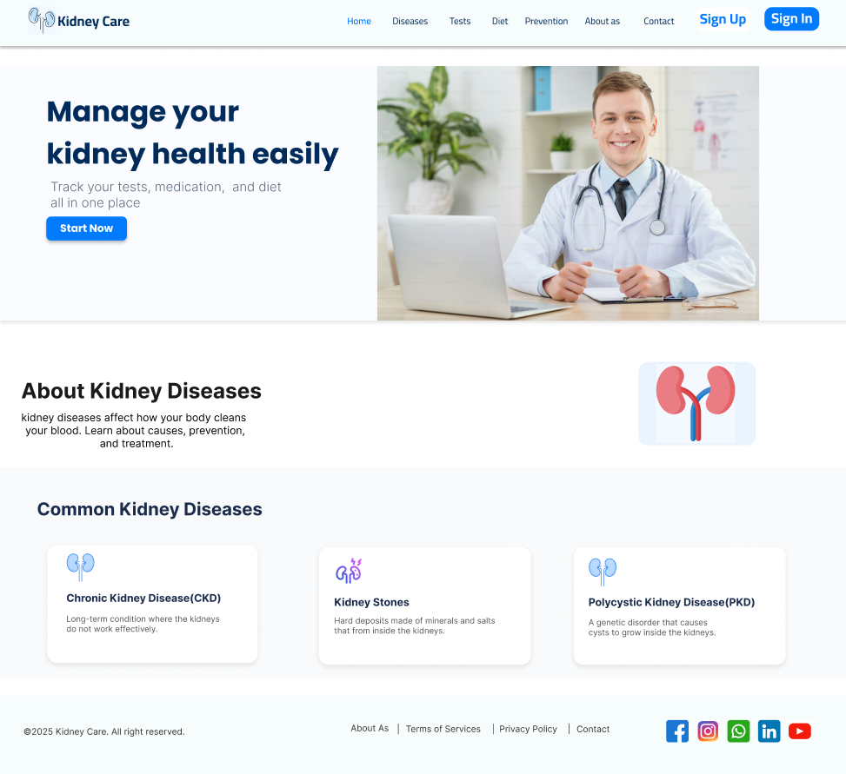
Authentication (Login & Sign Up)
Figure ‎3-1: Home page

To streamline the user experience, the Login and Sign-Up functionalities are combined into a single, dynamic component.
- Toggle Mechanism: Users can switch between "Login" and "Create Account" modes instantly without reloading the page.
- Dynamic Fields: The form adapts based on the mode selected. For example, the "Sign Up" mode reveals additional fields for First Name, Last Name, and Age.
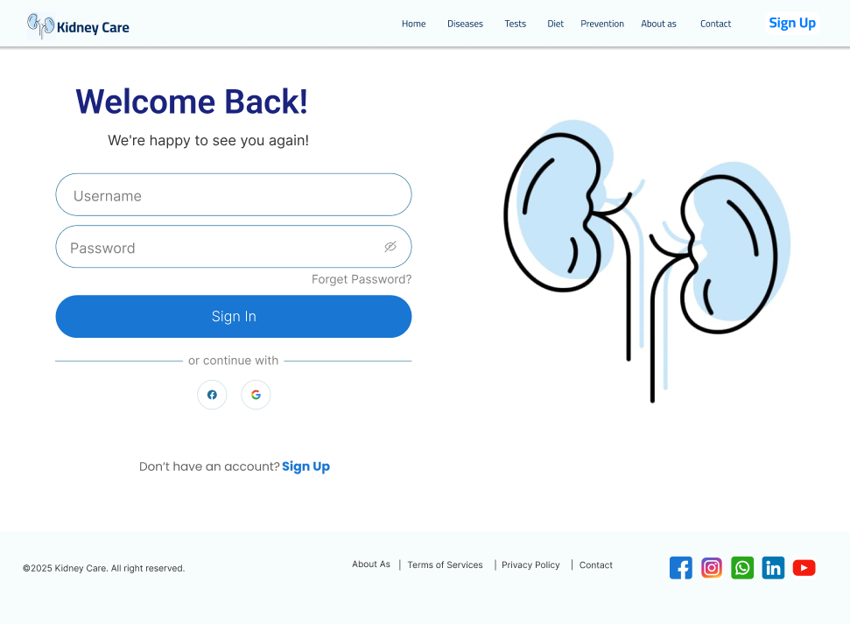
- Layout: The form is presented as a floating card alongside a thematic illustration, creating a balanced visual layout.
Figure ‎3-2: Login page

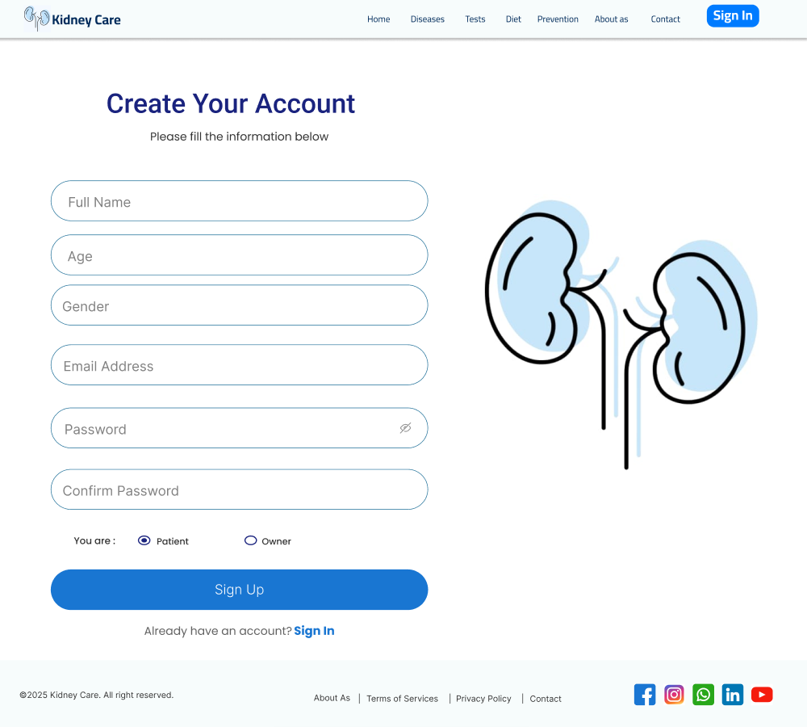
Symptom Checker (Tests)
Figure ‎3-3 : SignUp Page
This is the core functional page of the system where the AI integration takes place.
- Purpose: To collect health parameters from the user and display the prediction result.
- Key Elements:
  - Symptom Wizard: An interactive form displaying the 12 key symptoms (e.g., Blood Pressure, Specific Gravity, Appetite).
  - Selection Logic: Users select "Yes/No" or input numerical values for each symptom.
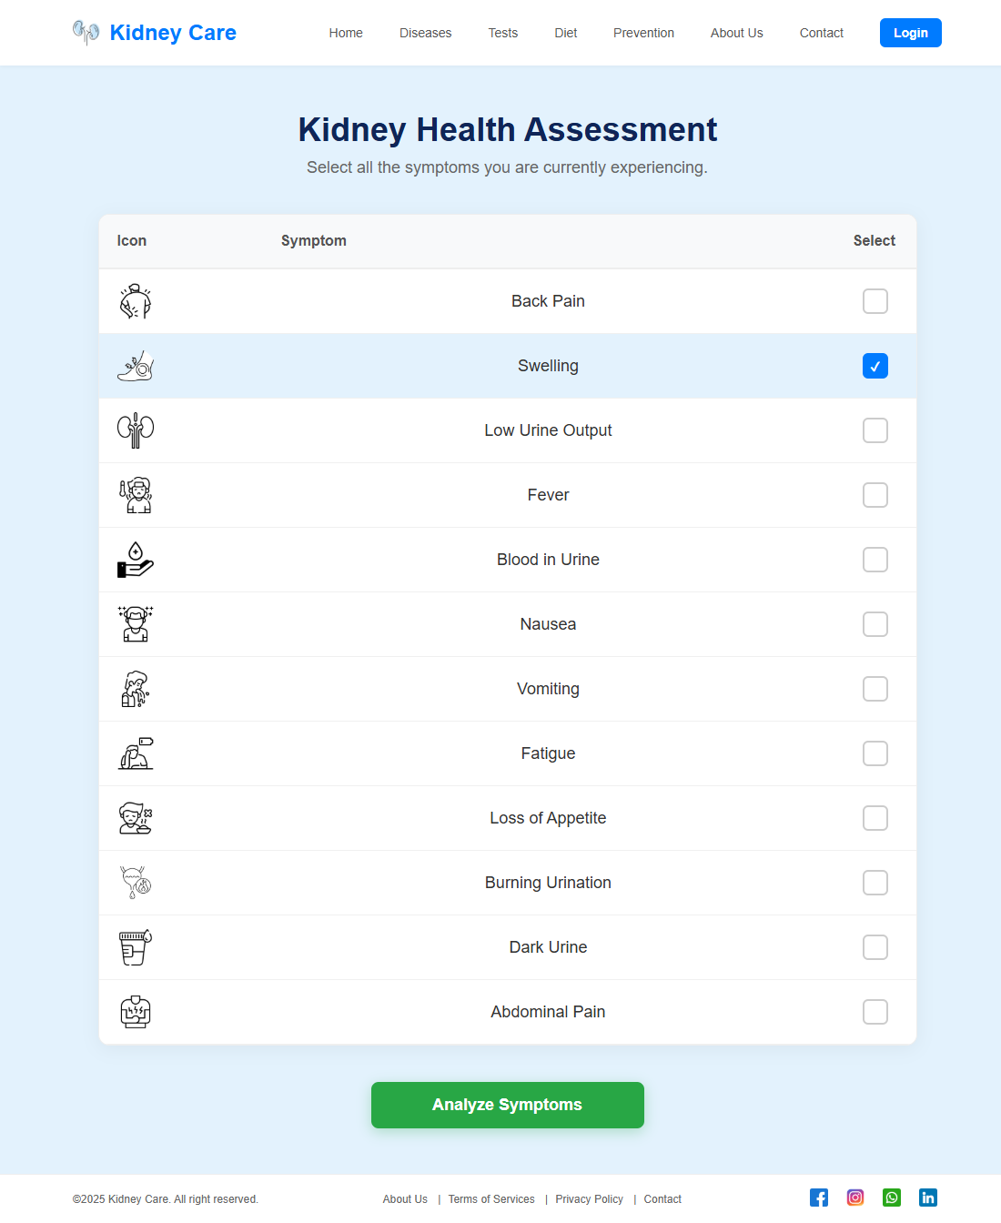
  - Result Modal: A pop-up or dedicated section that appears after submission, showing the AI's classification ("Healthy" or "Potential Chronic Kidney Disease").
Figure ‎3-4: Test Page

Diet & Prevention Pages
These educational pages utilize card-based layouts to present health information.
- Diet Page: Features a "Calories & Nutrients Tracker" with visual progress bars (Protein, Sodium, etc.) and lists of "Allowed" vs. "Avoided" foods.
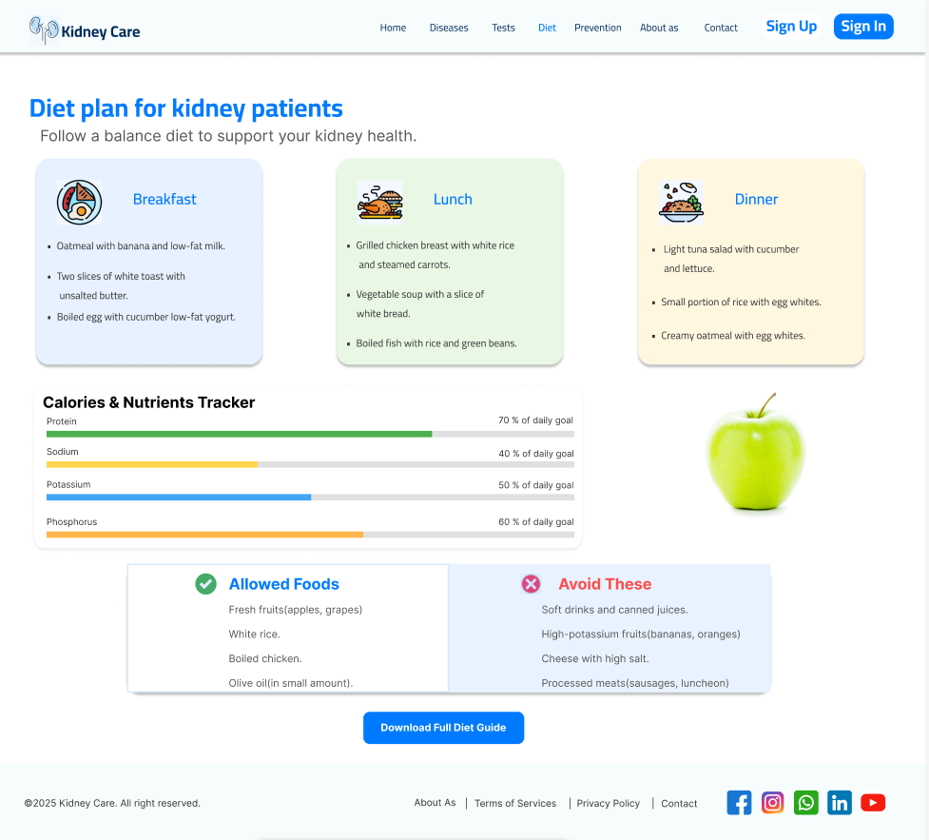
- Utilizes a grid layout to display prevention tips (e.g., "Drink Water," "Stay Active"), centered around a large anatomical illustration of kidneys.
Figure ‎3-5:Diet plan page

Contact Us Interface
The Contact Us page is designed to facilitate user communication through a structured, dual-column layout.
- Message Form: Located on the left, this section allows users to send direct inquiries. It includes fields for Name, Email, and a multi-line Message box. The form is contained within a light card to distinguish it from the background.
- Contact Information: The right column displays static contact details (Email, Phone, Location), each accompanied by a color-coded icon (Red) for quick visual scanning.
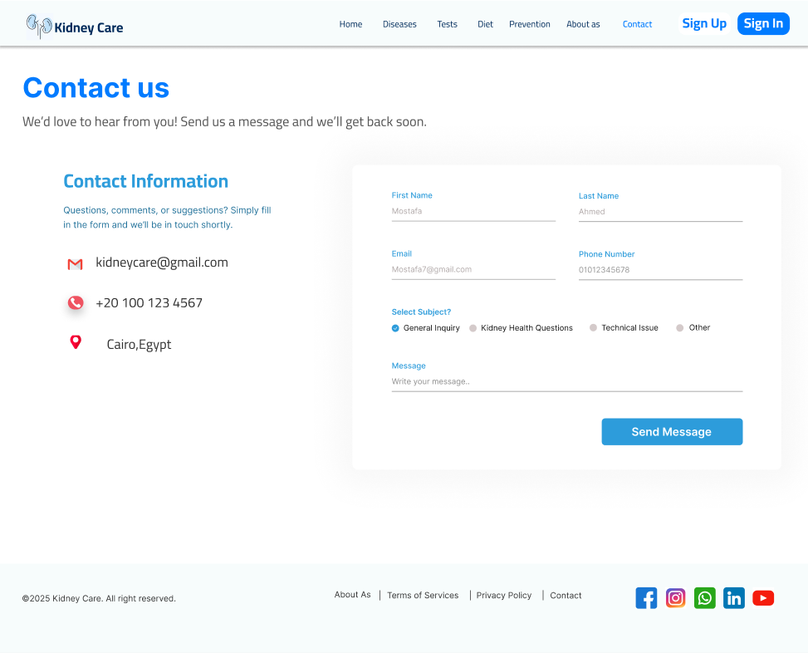
- Visual Balance: The layout uses whitespace effectively to separate the input area from the informational text, ensuring the page feels uncluttered
Figure ‎3-6:Contact page

About Us Interface
The About Us page establishes trust and authority. It is divided into three distinct visual tiers:
- Hero & Mission: A split-screen section featuring a high-quality medical team image alongside the organization's "Mission & Vision." The Mission/Vision text is enclosed in a bordered card for emphasis.
- Services Grid: A horizontal layout of cards highlighting core services: "Patient Support," "Awareness Programs," and "Expert Consultation." Each card features a relevant icon (Heart, Kidneys, Doctor).
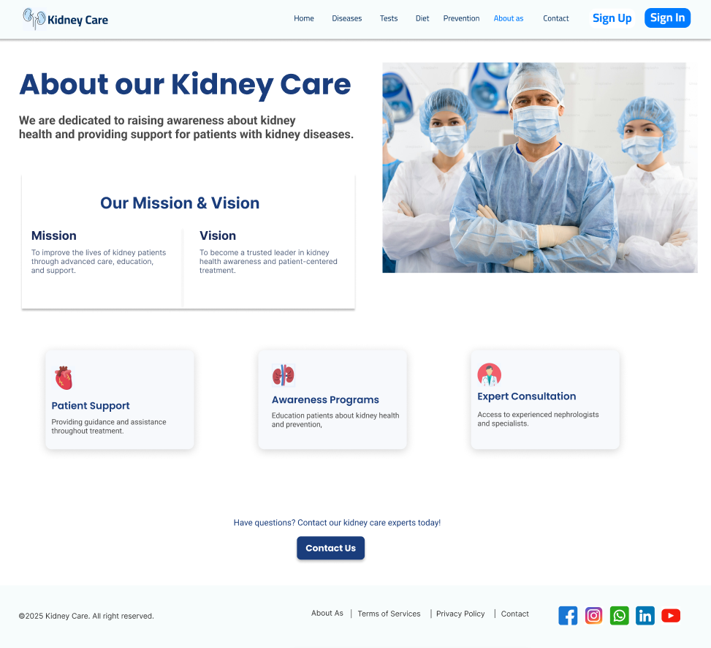
- Call to Action (CTA): A footer-adjacent section encouraging users to reach out, featuring a prominent "Contact Us" button that links directly to the Contact page.
Figure ‎3-7:About Our KidneyCare

User Profile Interface (Private Route)
The User Profile is a protected interface accessible only after successful authentication.
- Personalized Header: Displays the user's name and email alongside a generated avatar circle (using the user's initial).
- Data Summary: Lists specific user details such as Age and Account Status.
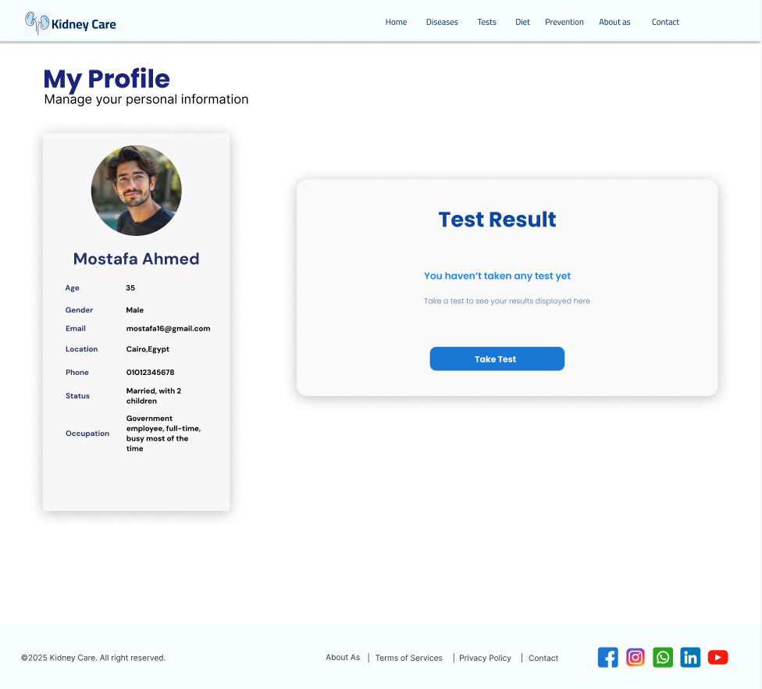
- Session Management: Includes a "Log Out" button that clears the user's session data from the browser, redirecting them back to the Home page for security.
Figure ‎3-8: Profile Page

Responsiveness
The application is built with a Mobile-First responsive design strategy. CSS Media Queries (@media (max-width: 1024px)) are implemented to ensure the layout adapts to tablets and smartphones.
- Flexbox & Grid: CSS Grid is used for the symptom cards to switch from a 4-column layout on desktops to a 2-column or 1-column layout on mobile devices.
Navigation: The layout adjusts padding and font sizes dynamically to ensure touch targets remain accessible on smaller screens.

Chapter 4

AI & ML

Module

Chapter 4 AI & ML Module

Introduction
The core intelligence of the Kidney Disease Diagnosis System relies on a sophisticated Machine Learning (ML) module. In modern medical diagnostics, the transition from manual, rule-based diagnosis to data-driven predictive modeling represents a significant leap in accuracy and efficiency. This chapter details the technical architecture, development lifecycles, and implementation of the AI component designed to classify five distinct kidney diseases based on clinical symptoms.
The objective of this module is not merely to provide a binary diagnosis (Sick/Healthy), but to offer a probabilistic assessment of the patient's condition. By analyzing 12 specific clinical features, the system utilizes supervised learning algorithms to map symptom patterns to specific disease classifications with a calculated confidence score.

Development Environment and Technology Stack
The module was developed using Python, the industry-standard language for Data Science, ensuring robust and scalable performance. The following libraries and frameworks constituted the core technology stack:

Scikit-learn (sklearn)
Scikit-learn is the primary library for building, training, and evaluating machine learning models.
- Function: Provided tools for Model Selection (Random Forest), Data Preprocessing (LabelEncoder), Data Splitting (train_test_split), and Model Evaluation (accuracy_score).

Pandas (pandas)
This library is indispensable for data manipulation and analysis.
- Function: Utilized for Data Ingestion (reading the CSV dataset into a Data Frame), Data Cleaning, and efficiently Separating Features (X) from the Target variable (y).

NumPy (numpy)
NumPy is critical for high-performance numerical computing.
- Function: Used to handle the model’s core mathematical operations, converting user input (JSON format) into optimized numerical arrays, and mathematically identifying the highest probability class using functions like np.argmax().

Joblib (joblib)
This library is essential for streamlining the deployment process.
- Function: Performed Model Serialization—saving the fully trained Random Forest model into the .pkl binary file. This allows the system to load the model instantly on the server without retraining.

Flask (flask)
Flask is a micro-web framework used for application development.
- Function: Employed to build the RESTful API layer (app.py), hosting the trained model and enabling external systems (the project's main backend) to interact with the AI logic via standardized HTTP POST requests, returning a JSON response.

Data Engineering Pipeline

Dataset Generation and Engineering
A major design decision was the focus on clinical symptoms accessible to the user, rather than complex lab results. To address the lack of suitable public data, a custom dataset was meticulously engineered by aggregating and synthesizing clinical symptom patterns from various reputable medical sources.
- Structure: The data consists of 12 binary features (0 for symptom absence, 1 for symptom presence) mapped to five distinct kidney disease classes.

Data Splitting and Reproducibility
The data was scientifically partitioned to ensure the model’s ability to generalize to new, unseen patient cases.
- Method: The train_test_split function was used to allocate 80% of the data for training and 20% for rigorous testing and validation.
- Reproducibility: The random_state=42 parameter was set to guarantee that the splitting procedure remains identical across all environments, ensuring that the results are reproducible and verifiable.

Label Encoding and Mapping
The model requires numerical input for both features and targets.
- LabelEncoder Process: The LabelEncoder was used to transform the text-based disease names (e.g., "Kidney_Stones") into unique integer codes (e.g., 0, 1, 2, 3, 4). This numerical mapping is crucial for the model's mathematical calculations during training.
- Mapping: A static dictionary (FINAL_DIAGNOSIS_MAP) is then embedded in the application to translate the predicted integer code back into a human-readable diagnosis for the final user outpu

Model Development and Selection

Algorithm Justification: Random Forest Classifier
The Random Forest Classifier was selected as the optimal algorithm for this classification problem due to its balance of high
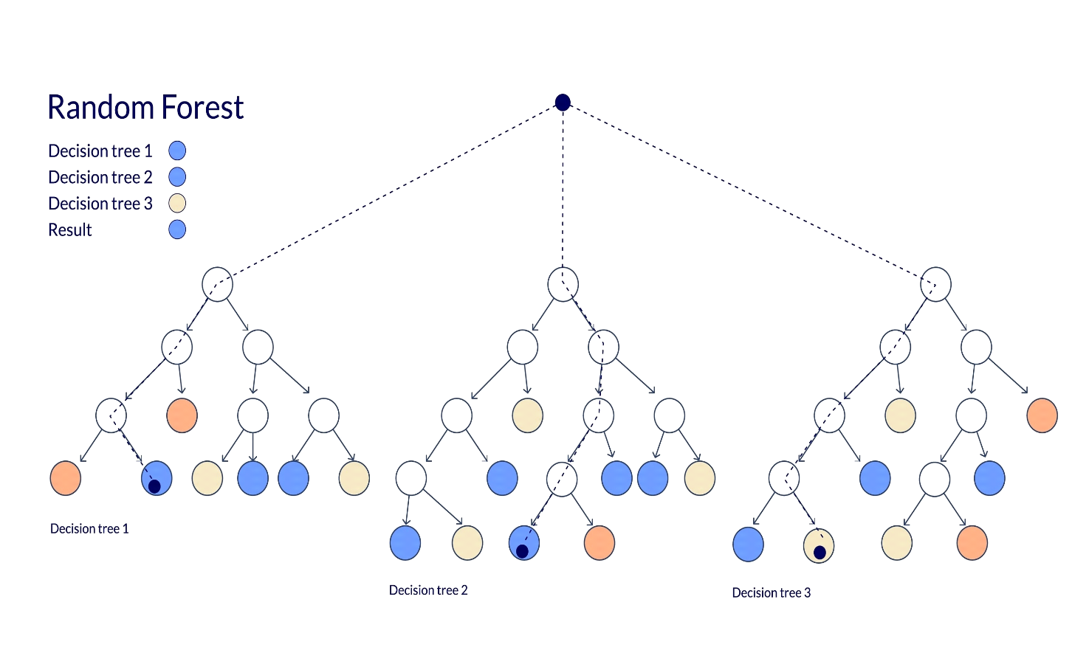
Core Mechanism: The Random Forest algorithm is an Ensemble Learning method that constructs a multitude of individual Decision Trees. During training, each tree is built using a random subset of data and features. The final prediction is determined by the majority vote of all trees.
Figure ‎4-1:Random Forest Architecture Diagram

Technical Advantages:
- High Prediction Accuracy: By averaging multiple decision trees, the model achieves superior accuracy compared to single-tree models.
- Overfitting Resistance: The ensemble nature inherently reduces the risk of overfitting, ensuring the model performs reliably on real-world, unseen patient data.
- Suitability for Tabular Data: The algorithm is exceptionally efficient and well-suited for structured data with binary and categorical features, aligning perfectly with our symptom-based dataset.
- Probability Output: Crucially, it supports the predict_proba() method, enabling the system to output the confidence score or probability of infection, rather than just a fixed label.

Training and Evaluation
The training phase involved fitting the model to the 80% training set. Post-training, the model was evaluated using the 20% test set, achieving a verifiable accuracy score of 74.00%. This score is considered robust and clinically reasonable for a preliminary diagnostic system relying solely on 12 binary, self-reported symptom features, demonstrating strong resistance to overfitting.

Model Deployment and API Workflow

API Implementation (app.py)
The Flask application (app.py) serves as the production environment for the model. Its core logic is dedicated to seamless integration:
- Model Loading: The script begins by instantly loading the pre-trained model artifact (.pkl) using joblib.load().
- Endpoint: A dedicated /predict endpoint handles incoming symptom data via HTTP POST requests.
- Inference: The core prediction logic is centered around calculating the full probability distribution and identifying the ID of the highest probability class.
- Mathematical Calculation: This logic is powered by model.predict_proba() and np.argmax().

JSON Response Structure
The output is a rich JSON response designed for easy consumption by the main backend application. It provides the diagnosis, confidence score, and a breakdown of all possibilities.
The AI module represents a successful application of machine learning techniques to a critical diagnostic problem, delivering a high-performance, easily integrable system capable of providing accurate and explainable probabilistic diagnose

Chapter 5

System Implementation

System Implementation

Introduction
This chapter provides a comprehensive technical description of the implementation phase of the "Kidney Diseases Awareness System". It details the transformation of the system design into a functional software product. The implementation utilizes a decoupled architecture where the Frontend (React.js), Backend (Node.js), and AI Engine (Python) operate as distinct services communicating via RESTful APIs.

Implementation Environment
The development and deployment of the system relied on the following specific tools and environments:
- Runtime Environments:
  - Node.js (v16.x): Chosen for its non-blocking I/O model, making it ideal for handling concurrent requests in the backend.
  - Python (v3.9): Selected for the AI engine due to its extensive support for data science libraries (Scikit-learn, Pandas).
- Frameworks & Libraries:
  - Express.js: A minimal and flexible Node.js web application framework used to structure the API.
  - Mongoose: An Object Data Modeling (ODM) library for MongoDB and Node.js to manage data relationships and schema validation.
  - React.js: A JavaScript library for building the user interface based on reusable components.
  - Flask: A micro web framework written in Python, used to serve the Machine Learning model.
- Development Tools:
  - Visual Studio Code: The primary Integrated Development Environment (IDE).
  - Postman: Used for testing API endpoints and debugging request/response payloads.
  - MongoDB Compass: A GUI for visualizing and managing the database data.

Backend Implementation
The backend system is the core of the application, engineered using Node.js and the Express.js framework. It is designed around a scalable Model-View-Controller (MVC) architecture to ensure separation of concerns and maintainability.

Project Architecture & File Structure
The codebase is organized into logical modules, allowing for efficient debugging and feature expansion. The structure implemented is as follows:
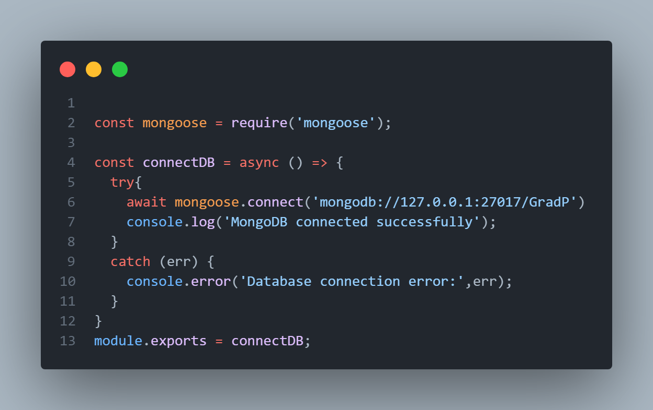
- config: Contains connection.js, which handles the asynchronous connection to the MongoDB database using Mongoose.
Figure ‎5-1:config
- controllers: Houses the business logic. Key controllers include:
  - user. Controller: Manages user authentication (Sign Up, Login) and profile updates.
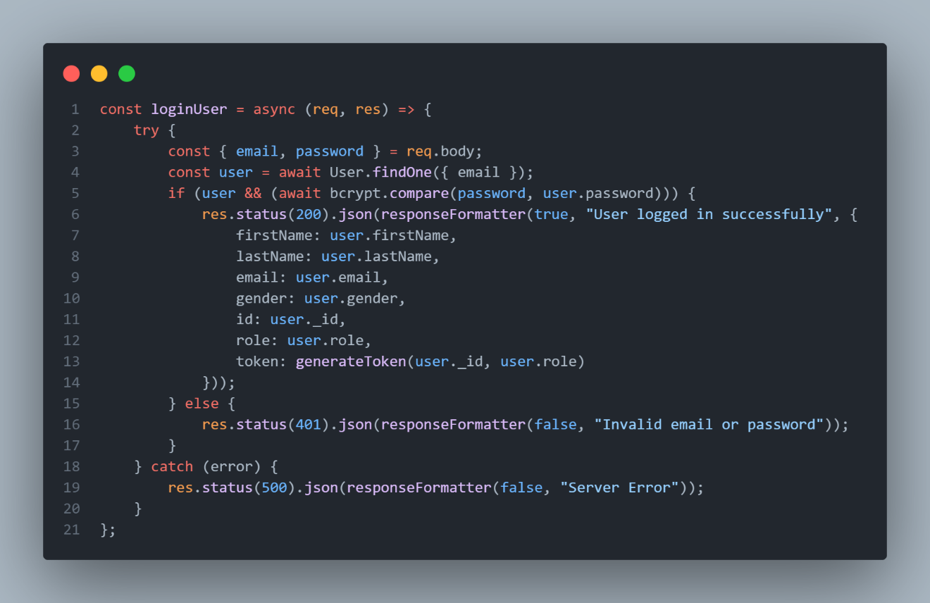
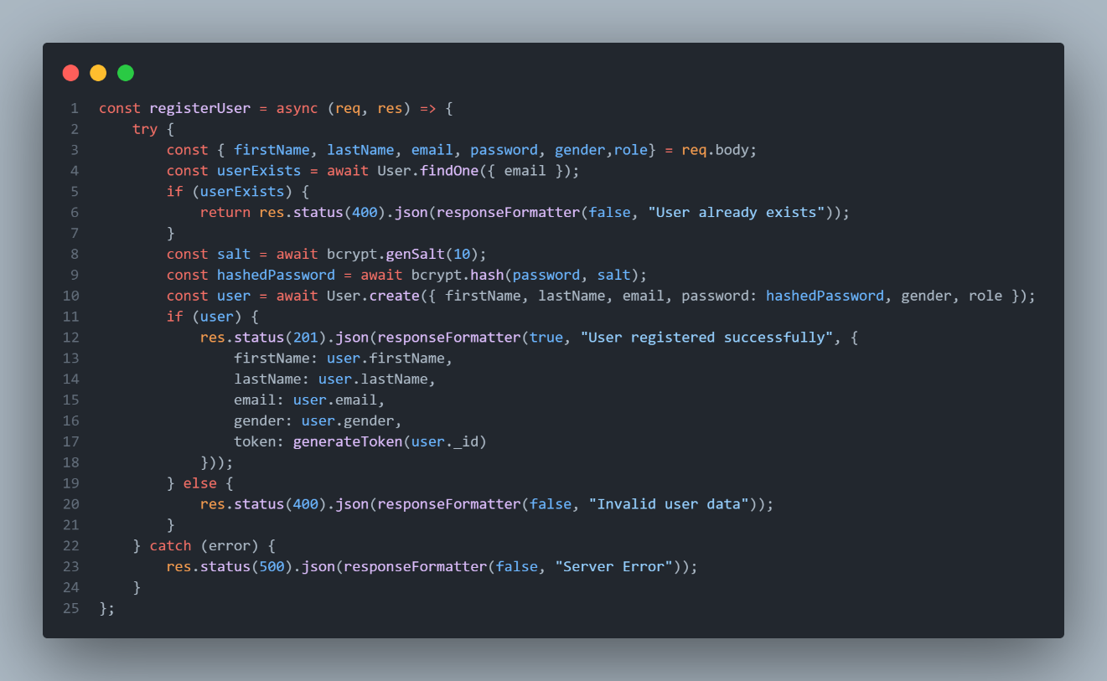
Figure ‎5-2: Login

Figure ‎5-3:Sign Up

- diagnose Controller: Processes symptom data and bridges the connection to the AI engine.
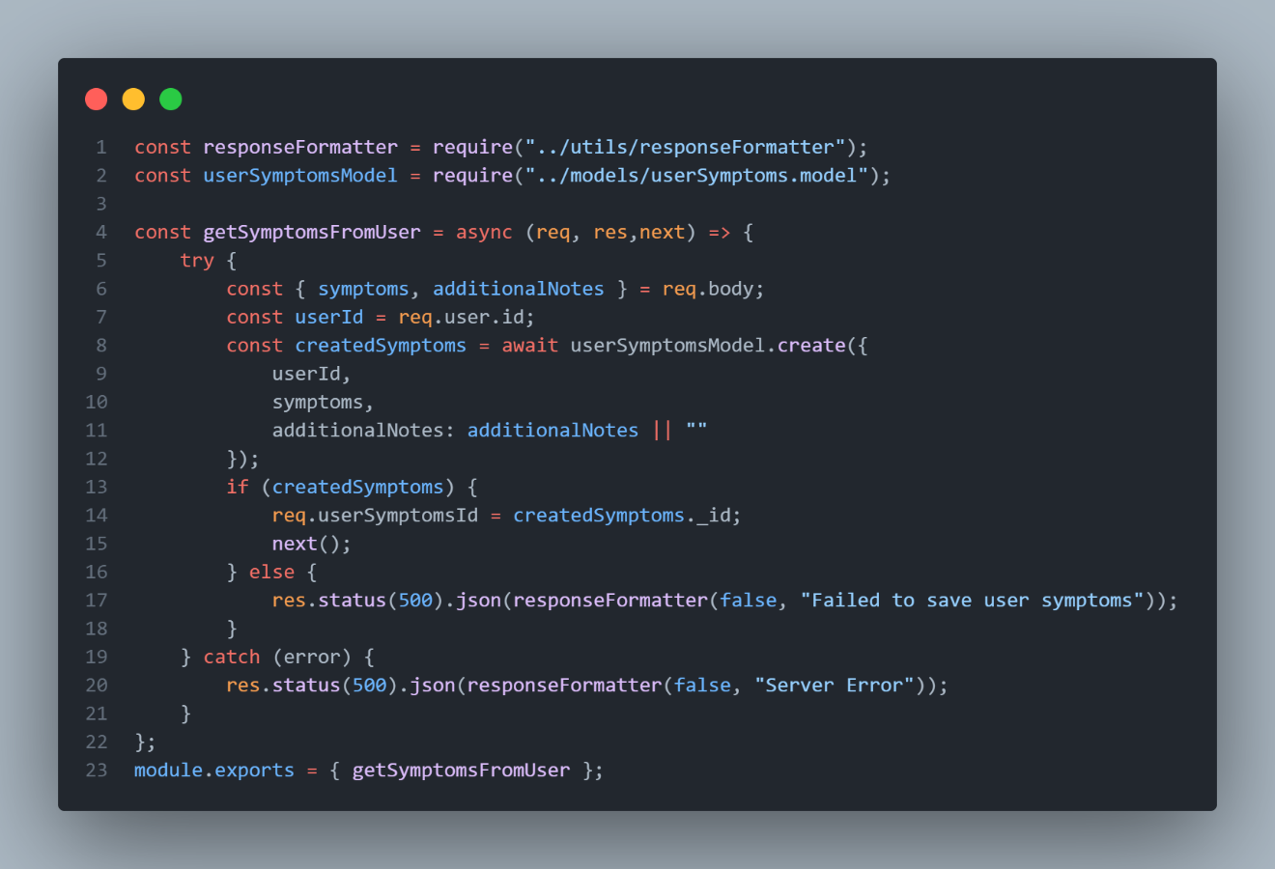
- Symptoms Controller: Fetches available symptoms dynamically.

Figure ‎5-4:use Symptom Controller

- models: Defines the NoSQL database schemas (user.model.js, diagnosis.model.js) ensuring strict data typing.
- routes: Maps HTTP endpoints to their respective controller functions (user.routes.js, diagnose.route.js).
- middleware: Custom middleware for request processing:
  - user.middleware.js: Verifies JWT tokens for protected routes.
  - rouleStatus.middleware.js: Implements Role-Based Access Control (RBAC) to distinguish between 'User' and 'Admin' privileges.
  - validation.js: Validates request body payloads using Joi/Express-validator.

Security & Authentication Module
Security is implemented using industry-standard protocols to protect patient data.
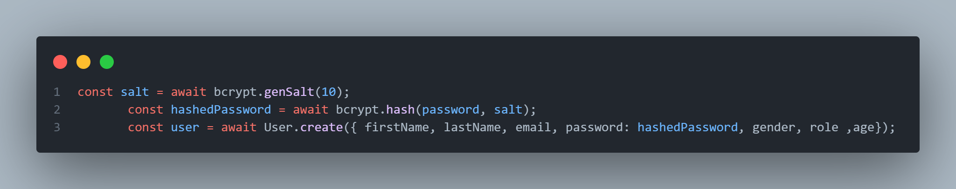
- Password Hashing: In user.controller.js, user passwords are hashed using bcrypt before storage, ensuring that raw passwords are never saved in the database.
Figure ‎5-5: password hashing

- JWT Implementation: Upon successful login, the system utilizes the utils/generateToken.js module to issue a JSON Web Token (JWT) signed with a secure JWT_SECRET.
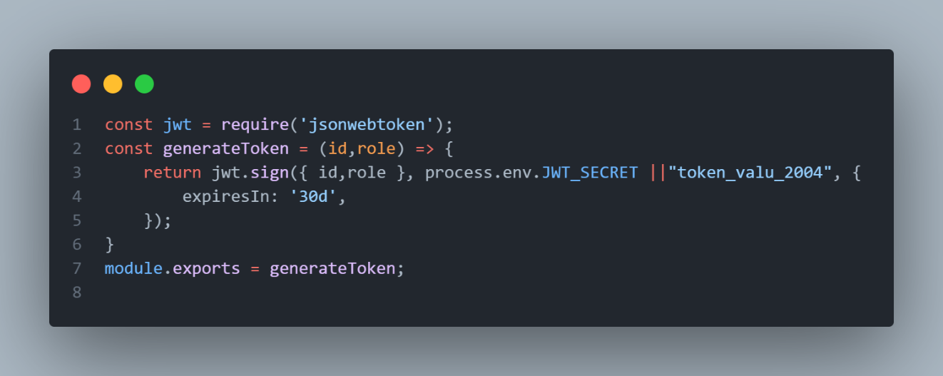
Figure ‎5-6:Token Generate
- Access Control: The rouleStatus.middleware.js inspects the user's role attached to the request. It restricts sensitive endpoints (like system configuration) to Admin users only, rejecting unauthorized access with a 403 Forbidden status.
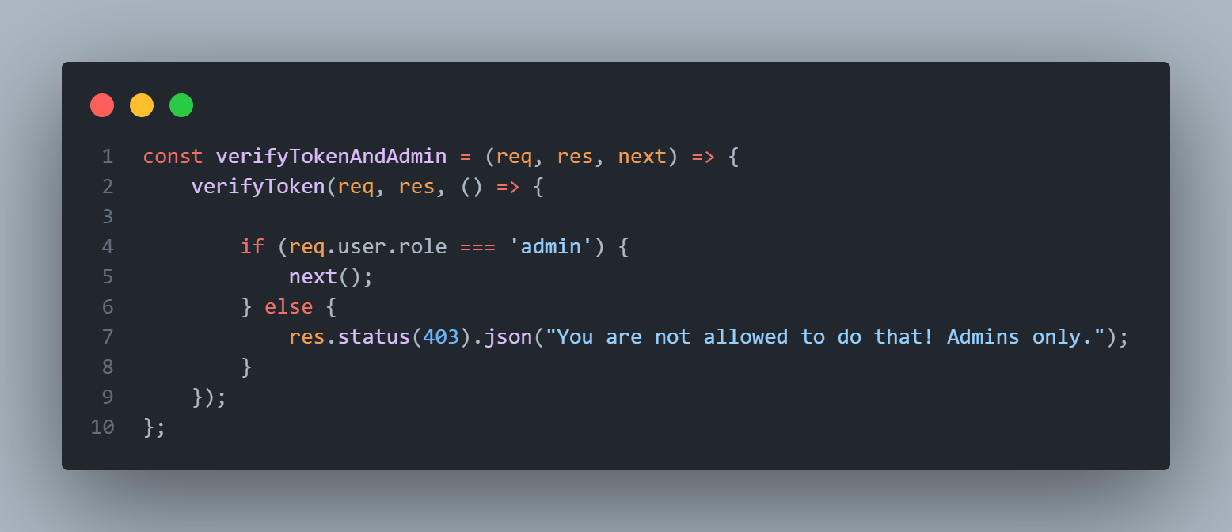
Figure ‎5-7:Verify Token Admin

The Diagnosis Logic (Core Feature)
The core functionality of the system is the AI-based Diagnosis, which is managed by the diagnose Disease function within the diagnose.controller.js file. This controller acts as the orchestrator, managing the data flow between the client-side interface, the MongoDB database, and the external AI microservice.
The logic is designed to be asynchronous and fail-safe, ensuring that user data is preserved even if the AI service encounters a temporary downtime.

Workflow Description
The diagnosis process follows a strict sequential logic to ensure data integrity:
- Input Reception & Validation: The controller receives the symptom vector (a map of binary values) and optional notes from the request body. Before processing, the validateDiagnosisInput middleware ensures the data structure is correct and contains valid numeric values (0 or 1) .
- Symptom Persistence (Step 1): Unlike traditional systems that process data immediately, this system first saves the raw symptoms into the UserSymptoms collection. This creates a permanent record of the patient's input, which is crucial for medical history tracking.
- AI Microservice Interaction: The system utilizes the axios library to send an HTTP POST request to the Python/Flask server running on port 5000. The payload contains the structured symptom data required by the Random Forest model.
- Prediction Handling: The system awaits the response from the AI engine, which includes the predicted_disease and a confidence score .
- Diagnosis Persistence (Step 2): Upon receiving a successful prediction, the system creates a new document in the Diagnosis collection. This document links the User ID, the Symptom Record ID, and the AI Result, creating a relational map between the input and the output .

Implementation Code
The following code snippet demonstrates the implementation of this logic, highlighting the separation of the symptom saving process from the AI inference call
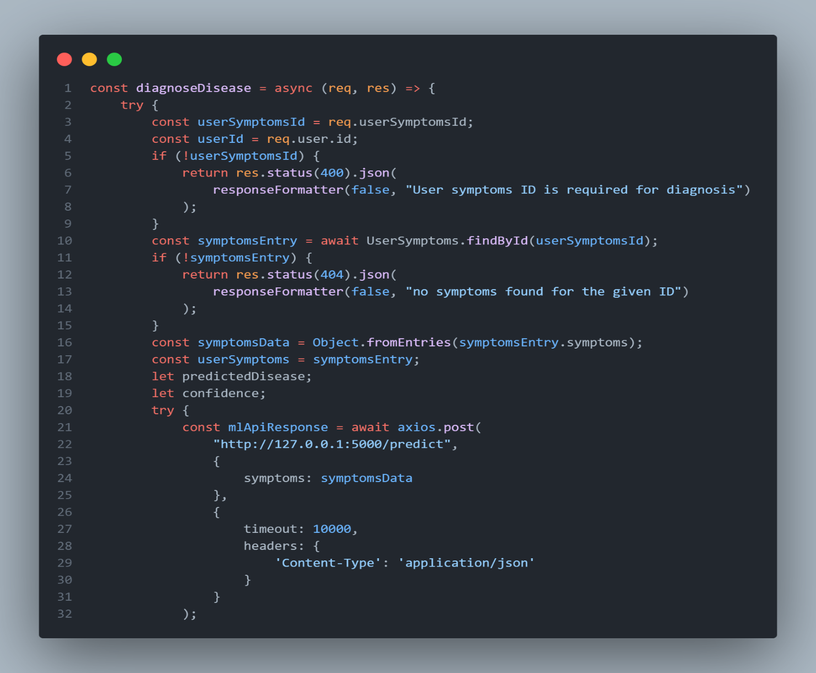
Figure ‎5-8:Diagnosis Controller Implementation

Error Handling Strategy
Robust error handling is implemented using try-catch blocks. If the AI microservice fails to respond within the defined timeout (10 seconds) or returns an error, the system catches the exception. Instead of crashing, it returns a 503 Service Unavailable status but ensures the user is informed that their symptoms have been successfully saved for future reference.

Database Connectivity
The system uses Mongoose for Object Data Modeling (ODM). The connection logic in config/connection.js establishes a persistent pool of connections to the MongoDB cluster, handling reconnection events and errors gracefully to ensure high availability.

API Documentation (Key Endpoints)
The backend exposes the following RESTful API endpoints for frontend consumption:
Method | Endpoint | Controller File | Description
POST | /api/user /register | user.controller.js | Registers a new patient account.
POST | /api/user/login | user.controller.js | Authenticates user and returns JWT.
GET | /api/symptoms | symptoms.controller.js | Retrieves list of checkable symptoms.
POST | /api/diagnose | diagnose.controller.js | Submits symptoms for AI analysis.

AI Engine Implementation (Python Service)
Since the Machine Learning model (Random Forest) is built in Python, a separate microservice was implemented to host it.

Model Serialization
The Trained Random Forest model was saved as a .pkl (pickle) file. This allows the system to load the pre-trained weights without needing to retrain the model for every request.

Flask API Integration A lightweight Flask server was created to expose the model.
- The /predict Endpoint: This POST route accepts a JSON object containing patient features.
- Data Preprocessing: Inside the route, the incoming JSON data is converted into a NumPy array or a Pandas Data Frame. Any necessary scaling or encoding (matching the training phase) is applied here.
- Inference: The loaded model's .predict() method is called with the processed data.
- Response: The predicted class (e.g., 0 for Healthy, 1 for Chronic Kidney Disease) is returned as a JSON response to the Node.js backend.

Frontend Implementation
The application is built as a Single Page Application (SPA) using React.js. It relies on a component-based architecture where the UI is decomposed into independent, reusable pieces.

Component-Based Architecture
The application structure is organized to maintain modularity. Key components include:
- Header & Footer: Shared components rendered on every page. The Header accepts props ( showLogin , isLoggedIn) to dynamically toggle between the "Login" button and the "User Profile" icon.
- Login & signup: Manages the authentication interface. It uses the use State hook to toggle a Boolean state (is Login), conditionally rendering the HTML DOM elements for either Registration or Login fields within the same component.
- Tests: Implements the core symptom checker logic. It manages an array of symptom objects and tracks the user's binary selection state (1 for present, 0 for absent).
- Profile: A protected component that fetches and displays the user's prediction history from the backend.

State Management
React Hooks are utilized extensively to manage the application's data flow:
- useState: Used to track user inputs, form toggles, pagination indexes and symptom selections.
- useEffect: Triggers side effects, such as checking for an existing JWT token in localStorage upon application load to persist the user's login session.
- useNavigate: Provided by React Router to programmatically redirect users (redirecting to /profile after a successful login).

Asset Management (Public Folder Strategy)
To resolve path resolution issues common in modern bundlers (Webpack), static assets (images, icons) are served from the public/assets/ directory. This allows components to reference images using absolute paths (e.g., src="/assets/image.png"), ensuring stability across different routes

Backend Integration & API

The Diagnosis Endpoint
The core functionality links the frontend symptom selector to the backend logic via the Fetch API.
- Data Formatting: When the user clicks "Analyze Symptoms," the frontend converts the selected symptoms into a binary JSON payload. a. Example :
Payload: { "back_pain": 1, "swelling": 0, "fever": 1 ... }
- API Call: An asynchronous POST request is sent to the backend endpoint http://localhost:5000/predict.
- Server Processing: The Node.js server uses body-parser to interpret the JSON. It processes binary inputs (currently using rule-based logic, designed to be replaced by an ML model inference).
- Response: The server returns a JSON object containing the prediction
(e.g., { "prediction": "High Risk"}), which is then displayed to the user via an alert or modal.

Server-Side Logic (Node.js)
The backend server (server/test.js) is initialized using Express. It is configured to listen on Port 5000 to avoid conflicts with the React frontend (Port 3000). • CORS Configuration: The server utilizes the cors middleware to permit requests specifically from the frontend domain, preventing security blocks during cross origin resource sharing.

Persistence Layer
To simulate a persistent user session without a full database implementation in the prototype phase, the browser's Local Storage is utilized.
- Login: When a user logs in, their details are serialized into a JSON string and stored in local Storage under the key "user".
- Session Check: App.js checks for this key on initialization to maintain the "Logged In" state in the navigation bar.
- Logout: Clicking logout removes this key and resets the application state.

Routing & Navigation Architecture
The application utilizes React Router DOM (v6) to manage navigation without page reloads. The routing logic is centralized in the App.js file.

Route Definitions
Routes are defined to map specific URL paths to React components. The architecture supports both public and protected user flows.
Route Path | Component | Access Level | Description
/ | Home.jsx | Public | Landing page with general info.
/login | Loginsignup.jsx | Public | Authentication portal.
/tests | Tests.jsx | Public | Interactive Symptom checker tool.
/diet | Diet.jsx | Public | Nutritional management advice.
/profile | Profile.jsx | Protected | User dashboard displaying history.

Programmatic Navigation
The use Navigate hook is implemented to handle dynamic redirects:
- Post-Login: Upon successful authentication in LoginCard.jsx, the user is automatically redirected to /profile.
- Post-Logout: Upon clicking "Log Out" in Profile.jsx, the user is redirected to /.

Data Flow & Component Logic

Parent-Child Data Passing (Props)
To maintain consistency in the Navigation Bar across different states (Logged In vs. Logged Out), the application uses Props Drilling.
- State Origin: The isLoggedIn state is initialized in App.js.
- State Passing: This boolean state is passed down to every page component .
- State Consumption: Each page passes this prop to the Header component.
- UI Update: The Header conditionally renders either the "Login" button or the "User Profile" icon based on this value.

The Symptom Checker Algorithm (Tests.jsx)
The implementation of the diagnosis test involves complex state handling:
- Data Structure: An array of objects defines the 12 symptoms, mapping readable labels ("Back Pain") to backend IDs (back_pain).
- Pagination Logic: To improve UX, the array is sliced into chunks of 4 items using JavaScript logic (slice(indexOfFirst, indexOfLast)). Navigation buttons update a current Page state variable to cycle through these chunks.
- Selection State: User inputs are stored in a key-value object (e.g., { back_pain: 1, fever: 0 }). When a card is clicked, the state updates dynamically to toggle the specific symptom's value.

Deployment & Environment
- Frontend Environment: The application is built using create-react-app and runs on a local Node.js development server (Port 3000).
- Backend Environment: The API server runs on a separate Node.js instance (Port 5000), utilizing nodemon for hot-reloading during development.
- Asset Hosting: All static assets (images, icons) are served from the public/assets directory to bypass Webpack module bundling restrictions, allowing for dynamic absolute path referencing.

Capter7

Conclusion

Conclusion

Conclusion
The "Kidney Diseases Awareness System" was developed to address the critical gap in public health awareness regarding renal disorders. By leveraging modern web technologies and Artificial Intelligence, the project successfully created an accessible, interactive, and educational platform.
The system achieved its primary objectives by:
- Bridging the Knowledge Gap: Providing simplified, scientifically accurate information about kidney diseases to the general public.
- Early Detection: Implementing a Machine Learning module (Random Forest) that analyzes user symptoms with 74% accuracy, encouraging early medical consultation.
- Seamless Integration: Successfully integrating a MERN Stack (MongoDB, Express, React, Node.js) architecture with a Python-based AI microservice, demonstrating a robust full-stack solution.
- User-Centric Design: Delivering a responsive and intuitive user interface that ensures accessibility across different devices.
While the system serves as a powerful awareness tool, it is designed to support, not replace, professional medical diagnosis. It empowers users to take proactive steps towards their kidney health.
- 7.2 Challenges Faced
During the development lifecycle, the team encountered and overcame several technical and operational challenges:
- Dataset Limitations: Finding a comprehensive, public medical dataset for specific kidney symptoms was difficult. This required significant data engineering and preprocessing to create a reliable training set.
- Cross-Service Communication: Establishing a stable and secure connection between the Node.js backend and the Python (Flask) AI service required careful handling of asynchronous API calls and CORS configurations.
- Medical Accuracy: Ensuring that the educational content and AI predictions were medically relevant required extensive research and validation against reputable health source
  - References
- National Kidney Foundation. (2024). Kidney Disease: Causes, Symptoms, and Treatments. Retrieved from https://www.kidney.org
- Centers for Disease Control and Prevention (CDC). (2023). Chronic Kidney Disease Initiative. Retrieved from https://www.cdc.gov/kidneydisease
- React Documentation. (2024). Getting Started with React.js. Retrieved from https://react.dev
- Node.js Foundation. (2024). Node.js Documentation API. Retrieved from https://nodejs.org/en/docs
- MongoDB Inc. (2024). The MERN Stack Guide. Retrieved from https://www.mongodb.com/mern-stack
- Scikit-learn Developers. (2024). Random Forest Classifier User Guide. Retrieved from https://scikit-learn.org
- Flask Documentation. (2024). Flask: A microframework for Python. Retrieved from https://flask.palletsprojects.com
- MDN Web Docs. (2024). HTTP response status codes. Mozilla Foundation. Retrieved from https://developer.mozilla.org

